**Sample Questions**

Subject – Computer Science Workshop-1(CSE 2141)

NAME – DEEPTESH ROUT

Registration Number – 2341018166

Section – 23412G1 Branch – B. Tech (CSE)

1. (a) Create an HTML page to display "My Profile" as a heading with proper background and text

color (Remember: you are a student) as described below:

· Add a paragraph briefly describing you on the left side below the heading.

· Add a passport-sized image of yourself on the right side below the heading.

(b) Add a table containing your educational qualification (with the heading "My Qualifications"), including ongoing courses with proper border, size, and color.

. The column containing the Board/University should have an appropriate website link.

(c) Add another table below the qualification containing your personal data (with heading as

"Personal Profile") containing your father's name, mother's name, address, phone no., Email ID,

Aadhar number, etc., with proper border, size, and color. Write (a), (b), and (c) in a single question with proper comment lines.

HTML CODE :-

<!DOCTYPE html>

<head>

  <title> Deepteshrout Sample Question 1</title>

  <style>

        body {

            background-color: #f0f8ff;

            font-family: Arial, sans-serif;

            color: #333;

        }

        h1 {

            text-align: center;

            color: #2f4f4f;

        }

        .content {

            display: flex;

            justify-content: space-between;

            padding: 20px;

        }

        .profile-description {

            width: 60%;

            margin-right: 20px;

        }

        .profile-image img {

            width: 200px;

            height: 200px;

            border-radius: 50%;

            border: 2px solid #2f4f4f;

        }

        table {

            width: 100%;

            border-collapse: collapse;

            margin: 20px 0;

        }

        th {

            background-color: #2f4f4f;

            color: white;

            padding: 10px;

        }

        td {

            text-align: center;

            padding: 10px;

            border: 1px solid #2f4f4f;

        }

        table, th, td {

            border: 2px solid #2f4f4f;

        }

    </style>

</head>

<body>

    <h1>My Profile</h1>

    <div class="content">

        <div class="profile-description">

            <p>

                Hello! I am Deeptesh Rout, currently pursuing my Bachelor of Technology at ITER University. I am a passionate developer with a keen interest in backend and frontend technologies. I enjoy creating high-quality and user-friendly applications. I believe in continuous learning and strive to improve my skills to contribute to the tech community.

            </p>

        </div>

        <div class="profile-image">

            <img src="myimage.png" alt="Deeptesh Rout">

        </div>

    </div>

    <h2>My Qualifications</h2>

    <table>

        <tr>

            <th>Qualification</th>

            <th>Year</th>

            <th>Board/University</th>

            <th>Website</th>

        </tr>

        <tr>

            <td>Bachelor of Technology</td>

            <td>2023-2027</td>

            <td>ITER University</td>

            <td><a href="https://www.ITER.ac.in" target="_blank">www.ITER.ac.in</a></td>

        </tr>

        <tr>

            <td>Intermediate</td>

            <td>2023</td>

            <td>State Board</td>

            <td><a href="https://www.sseb.org" target="_blank">www.sseb.org</a></td>

        </tr>

        <tr>

            <td>Matriculation</td>

            <td>2021</td>

            <td>Jyothi Convent School</td>

            <td><a href="https://www.jyothiconvent.com" target="_blank">www.jyothiconvent.com</a></td>

        </tr>

    </table>

    <h2>Personal Profile</h2>

    <table>

        <tr>

            <th>Field</th>

            <th>Details</th>

        </tr>

        <tr>

            <td>Father's Name</td>

            <td>Mr. Deeptesh Rout</td>

        </tr>

        <tr>

            <td>Mother's Name</td>

            <td>Mrs. Swetaleena Rout</td>

        </tr>

        <tr>

            <td>Address</td>

            <td>Dharitri Nagar , Bhadrak </td>

        </tr>

        <tr>

            <td>Phone Number</td>

            <td>8260527645</td>

        </tr>

        <tr>

            <td>Email ID</td>

            <td>deepteshrout2004@gmail.com</td>

        </tr>

        <tr>

            <td>Aadhar Number</td>

            <td>XXXX XXXX XXXX XXXX</td>

        </tr>

    </table>

</body>

</html>

OUTPUT :-

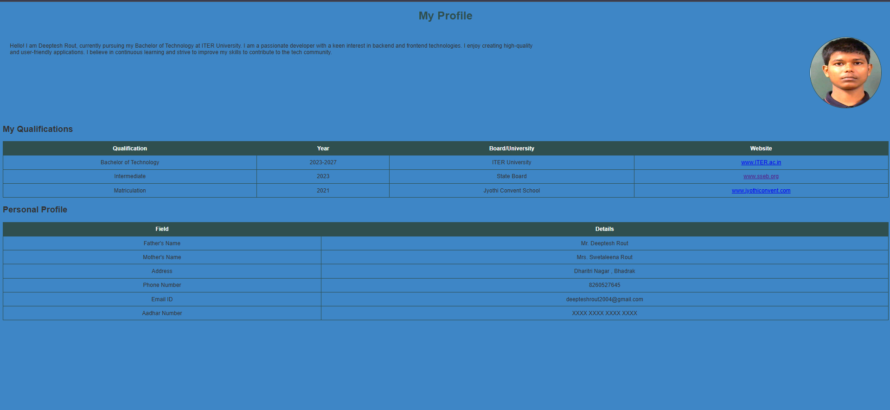

2. Write a jQuery program to perform the following actions on a <div> element: when the

user clicks on the <div>, its text should change to 'Clicked!'; when the user double-

clicks, the background color should change to orange; when the user hovers (mouse

enters) over the <div>, the border color should change to green; and when the user

moves the mouse away (mouse leaves), the border color should revert to black. The

<div> should initially have a light blue background, a black border, and centered text.

HTML CODE:-

<!DOCTYPE html>

<html lang="en">

<head>

    <meta charset="UTF-8">

    <meta name="viewport" content="width=device-width, initial-scale=1.0">

    <title> Deepteshrout Sample Question 2 </title>

    <style>

        body {

            font-family: Arial, sans-serif;

            background-color: #f4f4f9;

            text-align: center;

        }

        .container {

            width: 50%;

            margin: 0 auto;

            background-color: #fff;

            padding: 20px;

            border-radius: 8px;

            box-shadow: 0 4px 8px rgba(0, 0, 0, 0.1);

        }

        h1 {

            color: #2a3d63;

        }

        label {

            font-size: 16px;

            margin-top: 10px;

            display: block;

            text-align: left;

        }

        input[type="text"], input[type="email"], input[type="password"], input[type="number"], select {

            width: 100%;

            padding: 8px;

            margin: 10px 0;

            border: 1px solid #ccc;

            border-radius: 4px;

        }

        button {

            background-color: #4CAF50;

            color: white;

            padding: 10px 20px;

            border: none;

            border-radius: 4px;

            cursor: pointer;

            margin-top: 20px;

        }

        button[type="reset"] {

            background-color: #f44336;

        }

        button:hover {

            opacity: 0.9;

        }

        img {

            width: 150px;

            height: auto;

        }

    </style>

</head>

<body>

    <div class="container">

        <h1>Student Registration for SAAT-2024</h1>

        <img src="Siksha_‘O’_Anusandhan.png" alt="SOA University Logo">

        <form action="#" method="POST">

            <label for="firstName">First Name:</label>

            <input type="text" id="firstName" name="firstName" required>

            <label for="middleName">Middle Name:</label>

            <input type="text" id="middleName" name="middleName">

            <label for="lastName">Last Name:</label>

            <input type="text" id="lastName" name="lastName" required>

            <label for="fatherName">Father's Name:</label>

            <input type="text" id="fatherName" name="fatherName" required>

            <label for="address">Address:</label>

            <input type="text" id="address" name="address" required>

            <label for="phoneNumber">Phone Number:</label>

            <input type="number" id="phoneNumber" name="phoneNumber" required>

            <label for="email">Email ID:</label>

            <input type="email" id="email" name="email" required>

            <label for="tenthPercentage">10th Percentage:</label>

            <input type="number" id="tenthPercentage" name="tenthPercentage" required>

            <label for="twelfthPercentage">12th Percentage:</label>

            <input type="number" id="twelfthPercentage" name="twelfthPercentage" required>

            <input type="text" id="username" name="username" required>

            <label for="password">Password:</label>

            <input type="password" id="password" name="password" required>

            <label for="examCenter">Select Examination Center:</label>

            <select id="examCenter" name="examCenter" required>

                <option value="Balasore">Balasore</option>

                <option value="Rourkela">Rourkela</option>

                <option value="Sambalpur">Sambalpur</option>

                <option value="Berhampur">Berhampur</option>

                <option value="Rayagada">Rayagada</option>

                <option value="Paralakhemundi">Paralakhemundi</option>

                <option value="Bhawanipatana">Bhawanipatana</option>

                <option value="Puri">Puri</option>

                <option value="Cuttack">Cuttack</option>

                <option value="Bhubaneswar">Bhubaneswar</option>

            </select>

            <button type="submit">SUBMIT</button>

            <button type="reset">RESET</button>

        </form>

    </div>

</body>

</html>

OUTPUT :-

